# Multi Cavity vs. Family Injection Molds

# Introduction

By injecting molten material into a mold, the industrial method of injection molding enables the fabrication of parts in huge quantities. The substance, which is often a thermoplastic or thermosetting polymer, is heated, mixed, and then pressed into a mold cavity, where it cools and solidifies into the mold's form. The success of injection molding depends on selecting the proper type of mold since it influences the product's quality, cost, and manufacturing efficiency. Molds may be divided into many sorts according to the quantity and nature of the cavities they hold. Multi-cavity molds and family molds are two prevalent forms of mold.

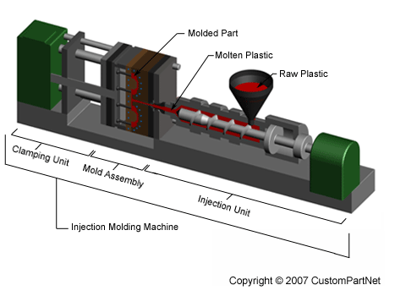

Figure 1 Major parts of Injection molding machine (source: https://www.custompartnet.com/wu/InjectionMolding)

A single injection molding cycle can produce many pieces of the same type using multi-cavity molds. Those molds have multiple identical cavities. For example, to make several bottle caps simultaneously, a multi-cavity mold can be used. Multi-cavity molds include several benefits such as shorter cycle time, cheaper cost per part, and greater design parts. Family molds contain a variety of cavities which allow the manufacturing of several related items of different types. This can be achieved in a single injection molding cycle. For instance, using family molds body and four wheels of toy automobiles can be created simultaneously. With family mold lower tooling cost and Production effectiveness can be achieved.

# Understanding Multi-Cavity Injection Molds

Injection molds with several identical cavities, or multi-cavity injection molds, enable manufacturing numerous pieces of the same type within a single injection molding cycle. A multi-cavity mold, for instance, may make four bottle caps at once. Multi-cavity injection molds operate similarly to single-cavity molds, with the exception that a runner system uniformly distributes the molten material throughout the many cavities. According to the material and mold design, the runner system, which comprises passages connecting the injection nozzle to the cavities, can be either cold or hot.

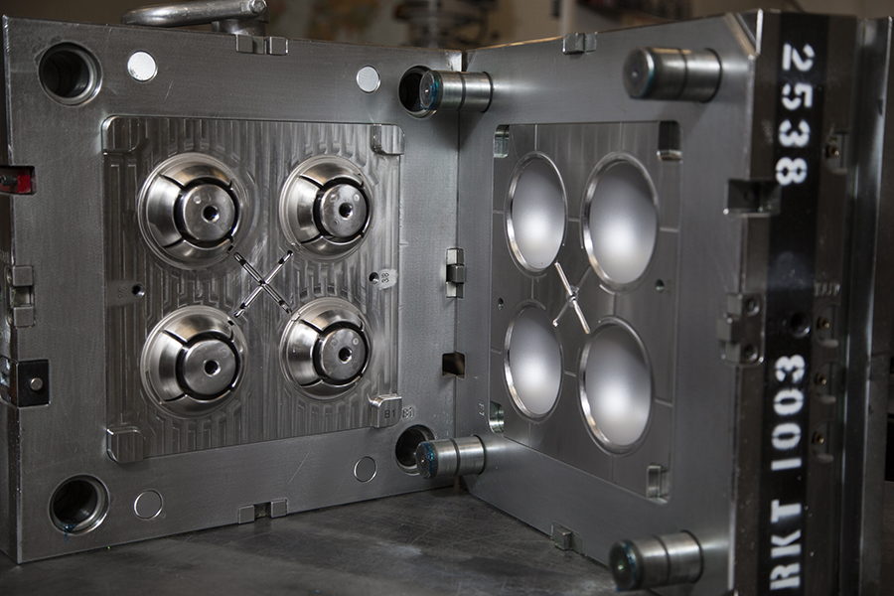

Figure 2 multi-cavity injection mold (source: https://www.kaso.com/everything-you-need-to-know-about-multi-cavity-injection-molds/)

Multi-cavity injection molds have a higher production rate as they can manufacture more components each cycle than single-cavity molds. In terms of large-scale manufacturing, this method is cost-effective because of lower cost per item, energy use, labour cost, and machine wear. As this method can provide consistent cooling, filling, and pressure across cavities, the uniformity and quality of the parts can be enhanced. Multi-cavity injection molds do, however, have significant drawbacks that must be taken into account. They need more intricate mold design, production, and maintenance than single cavity molds, which results in several drawbacks, one of which is that they have a high initial cost. Due to its ability to only generate components of the same size, shape, and material, multi-cavity injection molds also have restricted design freedom. Injection molds with several cavities can also provide certain technical difficulties, such as balancing the runner system, managing mold temperature, and avoiding parting line and flash problems.

# Understanding Family Injection Molds

Family injection molds are molds utilized in the process of injection molding to produce parts or components at the time. Designers create these molds to accommodate cavities or impressions within a mold allowing for the production of different elements, in a single molding cycle. The use of family injection molds brings both advantages and disadvantages, which depend on the production requirements and complexity of part designs.

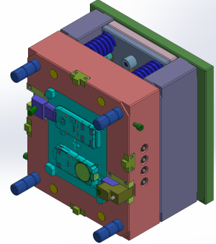

Figure 3 Family molds with two cases halve (Source: https://www.injection-moldings.com/groups/engineering-team/family-molds-benefits)

One notable advantage of family injection molds is their ability to produce parts simultaneously offering flexibility, in manufacturing. This not helps reduce tooling costs but also enhances production efficiency while facilitating modifications to individual components. Family injection molds are particularly well suited for low-volume production scenarios involving varied parts that demand variations or components for a specific assembly. One drawback of using family injection molds is the potential, for imbalances in filling, pressure, and cooling among the cavities. These imbalances can have an impact on the quality and consistency of the parts resulting in defects, like warping, shrinkage, flash, or short shots. It's important to note that family injection molds are best suited for parts that can be molded under conditions, including material type, temperature requirements, cycle time, and clamping force.

# Comparison between Multi-cavity Injection Molds and Family Injection Molds

Based on production requirements and needs, family injection and cavity injection molds have discrete benefits and drawbacks. In this section, two molds type will be compared in terms of production rate, cost efficiency, adaptability, and quality assurance.

## Production rate

Due to their ability to create more pieces each cycle than family injection molds, multi-cavity injection molds have a greater production rate. As a result, the injection molding process becomes more productive and efficient while cutting down on cycle time. For instance, whereas a family mold may simultaneously make one bottle cap and one bottle body, a multi-cavity mold can produce four bottle caps at once. In terms of production rate, the family injection mode can create fewer components in each cycle as compared to multi-cavity molds. Family injection molds offer versatility in making several pieces simultaneously, resulting in less material use in optimum time. For low-volume manufacture of intricate and varied parts with the need for a variety of modifications, family injection molds are considered suitable.

## Cost-effectiveness

In large-scale manufacturing, multi-cavity injection molds are more cost-effective than family injection molds because they may reduce the cost per item by cutting back on material waste, energy use, labour costs, and machine wear. However, since they require more intricate mold design, manufacturing, and maintenance than family injection molds, multi-cavity injection molds have a greater starting cost than family injection molds in small-scale manufacturing, family injection molds are more cost-effective than multi-cavity injection molds because they may cut tooling costs by including numerous pieces into a single mold. Family injection molds, however, cost more per component than multi-cavity injection molds because they prolong cycle times and result in more material waste, energy use, labour costs, and machine wear.

## Flexibility

In terms of part design and variation, multi-cavity injection molds are less flexible than family injection molds. The only pieces that multi-cavity injection molds can create are identically sized, shaped, and made of materials. This restricts the use of multi-cavity injection molds for the production of novel items or the customization of already existing products. Furthermore, once created, multi-cavity injection molds are challenging to replace or adjust since any change might compromise the mold's performance and balance. In terms of part design and variation, family injection molds are more flexible than multi-cavity injection molds. Family injection molds may create components in a variety of sizes, shapes, and materials. This enables the use of family injection molds to produce new items or modify ones that already exist. Family injection molds may also be changed or modified more easily once they are created since each cavity can be switched out or replaced without impacting the others.

## Quality control

In terms of component consistency and homogeneity, multi-cavity injection molds have greater quality control than family injection molds. Injection molds with many cavities may maintain consistent component quality and dimensions by ensuring that each cavity receives the same amount of cooling, filling, and pressure. By maximizing the mold design and process parameters, multi-cavity injection molds may help minimize flaws like short shots, sink marks, or warping. In terms of part consistency and homogeneity, family injection molds have weaker quality control than multi-cavity injection molds. In family injection molds, there may be an imbalance in the pressure, filling, and cooling throughout the cavities, which can lead to variations in the shape and size of the parts. Family injection molds can therefore provide items of low quality and great variance.

## Comparison summary

The table below sums up the key differences between multi-cavity and family molds.

Table 1 Differences between multi-cavity and family molds.

|  |  |  |
| --- | --- | --- |
|  | **Multi-cavity Molds** | **Family Molds** |
| **Production rate** | It's great, for speeding up production by making parts at the same time which helps reduce lead times, especially for high-volume manufacturing. | Can significantly reduce the assembly time by creating all associated parts together |
| **Cost-effectiveness** | The initial investment, for tooling can be quite high. It has the potential to lower the cost per part as the production volume rises. | The costs of tooling can be high. It helps avoid the need to create molds for each part. |
| **Design Flexibility** | While it has complexity it also has flexibility. | Higher complexity, but with higher flexibility as well. |
| **Part Quality** | The parts produced are of quality because there are design variations. | However, maintaining quality can be challenging due, to varying cooling requirements. |

# Case Studies

We will give some instances of multi-cavity injection molds and family injection molds being used successfully in the industry in this section.

## Successful use of Multi-cavity Injection Molds in the industry

One instance is Husky Injection Molding Systems' manufacturing of bottle caps, which makes use of injection molding technology. Husky produces high-quality and high-performing bottle caps in bulk using multi-cavity injection molds and hot runner systems. With cycle rates as low as 1.9 seconds, Husky's multi-cavity injection molds can manufacture up to 96 caps every cycle. The advantages of Husky's multi-cavity injection molds include less material waste, energy usage, and maintenance expenses.

Another illustration is Sino Mould Co., Ltd., a reputable plastic mold maker in China, which makes medical syringes. Sino Mould manufactures disposable syringes in a variety of shapes and sizes using multi-cavity injection molds with cold runner systems. With cycle speeds as quick as 5 seconds, Sino Mould's multi-cavity injection molds can make up to 128 syringes every cycle. The advantages of Sino Mould's multi-cavity injection molds include excellent accuracy, stability, and durability.

## Successful use of Family Injection Molds in the industry

One instance is Shantou Mengxing Package Machinery Co., Ltd., a top supplier of plastic thermoforming equipment and molds in China, which produces toy automobiles. Mengxing creates toy car bodies and wheels in a variety of hues and designs using family injection molds and cold runner systems. Injection molds from the Mengxing family have cycle durations as short as 15 seconds and can create one vehicle body and four wheels every cycle. Injection molds from the Mengxing family also provide benefits including lower tooling costs, increased manufacturing efficiency, and easier assembly.

NingBo's manufacturing of electrical switches is another such. Chinese electrical component and product producer ChenTe Electronics Technologies Co., Ltd. ChenTe manufactures switch housings and buttons in a variety of shapes and sizes utilizing family injection molds and hot runner systems. Injection molds from the ChenTe series have cycle durations as short as 8 seconds and can manufacture one housing and two buttons each cycle. Injection molds from the ChenTe family also include benefits including design freedom, quality assurance, and part switching.

# VI. How to Choose Between Multi-cavity Injection Molds and Family Injection Molds

This section consists of some recommendations on how to pick between family injection molds and multi-cavity injection molds.

## Assessing production needs

Assessing your manufacturing requirements, including the quantity, speed, and complexity of your products, is the first stage. Multi-cavity injection molds are a good choice if you need to make a lot of basic, homogenous parts with few changes at a greater production rate, reduced cost per part, and consistent component quality. Family injection molds are a good choice if you need to create small quantities of intricate and varied parts that need several variants or components for a certain assembly since they may save tooling costs, increase production efficiency, and make part changes easier.

## Considering design complexity

Consider the form, size, material, and look of your pieces, as well as their design complexity, in the second phase. You could use multi-cavity injection molds if all of your components are the same size, shape, material, and look since they can provide easy mold design, manufacturing, and maintenance. Family injection molds are a good choice if your components differ in terms of their sizes, weights, compositions, or aesthetics since they permit part design and variation flexibility.

## Evaluating cost factors

For the third phase, an evaluation of the project’s cost variable is needed, this includes the original investment, ongoing cost, and return on investment. For large-scale manufacturing with high production volume, multi-cavity injection molds can be cost-effective. Similarly, for small-scale manufacturing with modest production volume family injection molds can be cost-effective. This can be achieved by lower tooling costs.

# Conclusion

In this article, two types of injection molds that are commonly used in industry: multi-cavity injection molds and family injection molds are explored. Working principles, advantages and disadvantages, cost-effectiveness, and applications of those molds for injection molding have been compared and contrasted. A few case studies on the production usage of these mold types in the industry are also included. Additionally, some recommendations for selecting one of those injection molding for injection molding is provided. Choosing the right type of mold is considered important because it affects the quality, cost, and efficiency of the product. If the wrong type of mold is chosen, it can end up with defective parts, wasted material, increased expense, and reduced productivity. Therefore, it’s important to evaluate the production needs, design complexity, and cost factors before molds. By choosing the right type of mold, the injection molding process can be optimized and can achieve the best outcomes and return on investment.